Missing Element:

Prompt for list length -> iterate integer input into list -> copy list -> delete random element from original -> print original, copy, and set difference

Using the "random" class, a list of user-determined length is instantiated by taking user input. Upon completion, it is copied, and a random element within it is deleted. Then, by finding the symmetric difference between the original list and its copy, the missing element is discovered, and the results are displayed.

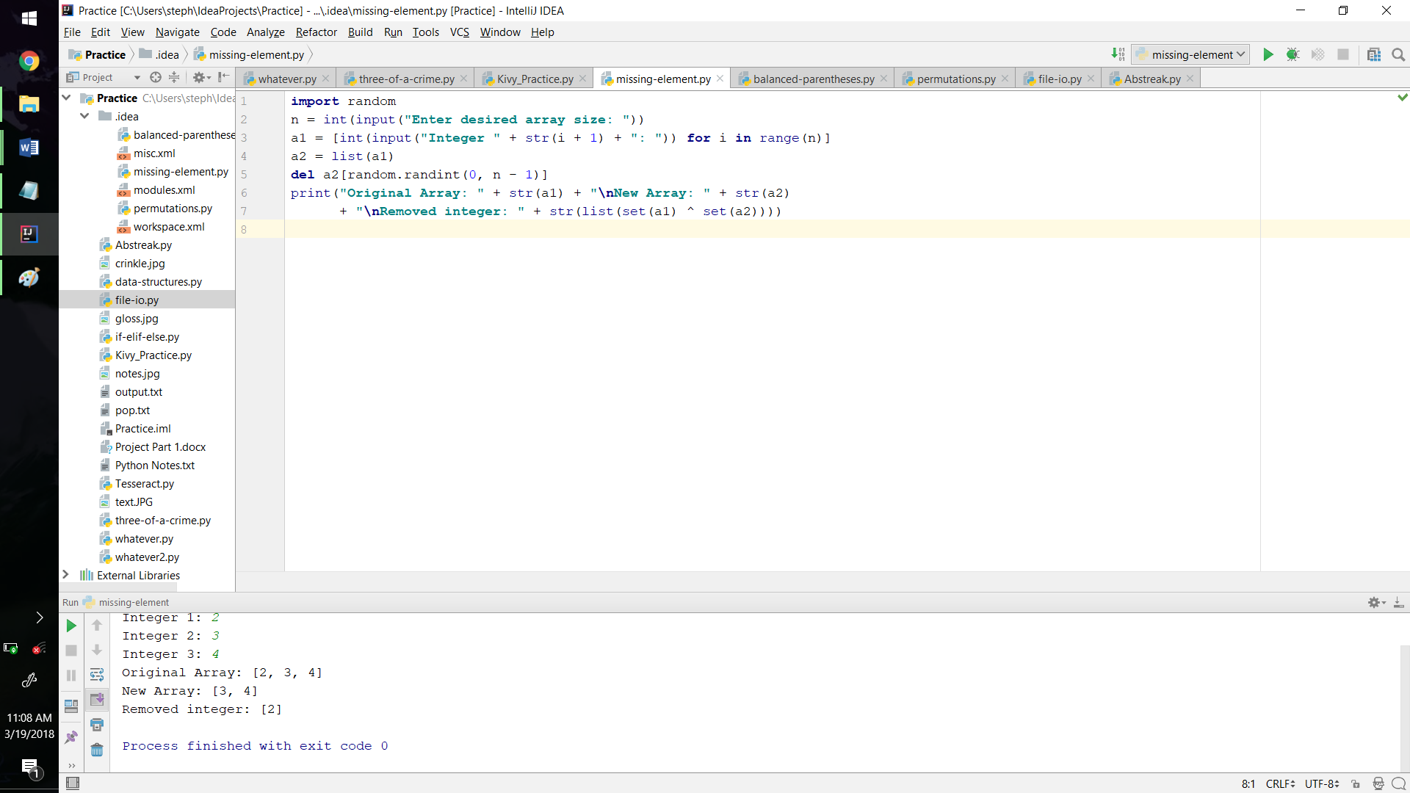

Balanced Parentheses:

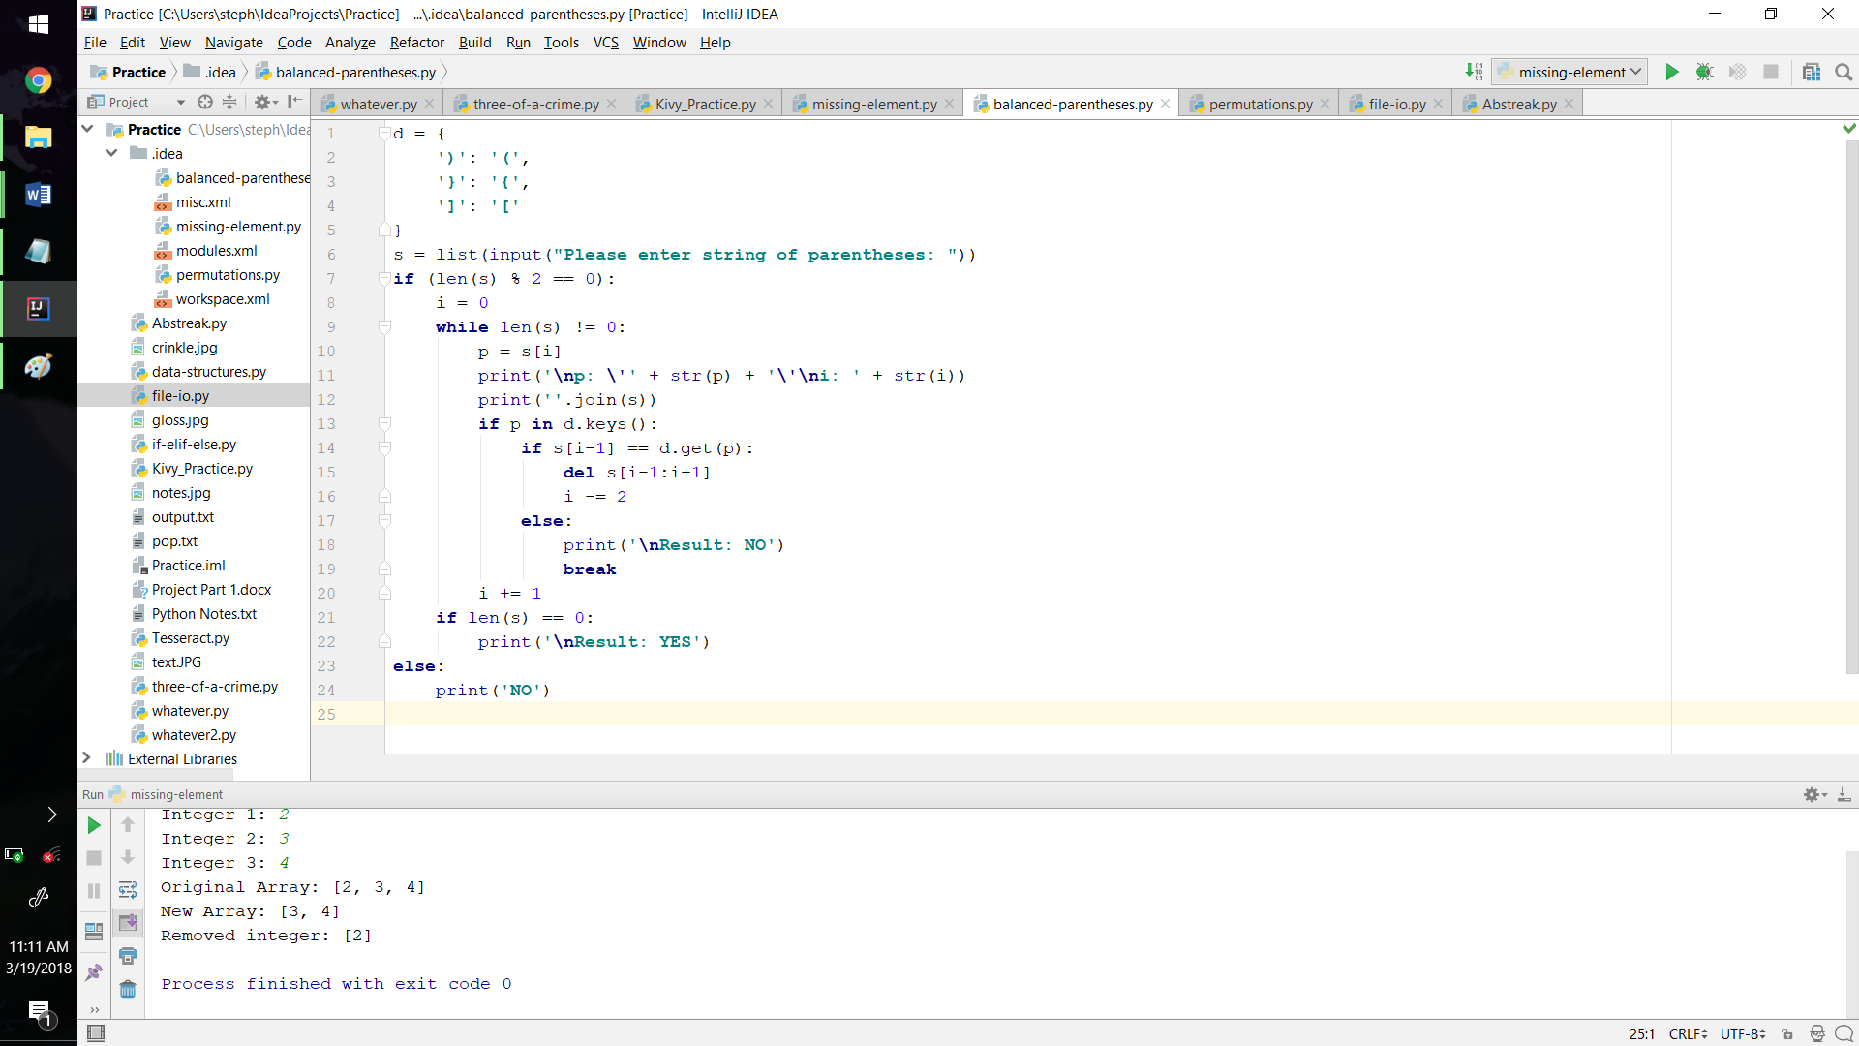Prompt for parentheses string -> check if length is even -> find first closing parenthesis -> check if preceding character is a matching opening parenthesis -> delete both -> repeat until empty -> (any conditionals that return false prove string's invalidity)

The program procedurally checks first if the string's length is even. If so, the program enters a while loops that terminates successfully if the string is completely "eaten." Within the loop, the first closing parenthesis is found, and, if the preceding character is a matching opening parenthesis, the two are deleted. Repeating these steps will accurately render a string of balanced parentheses.

Permutations:

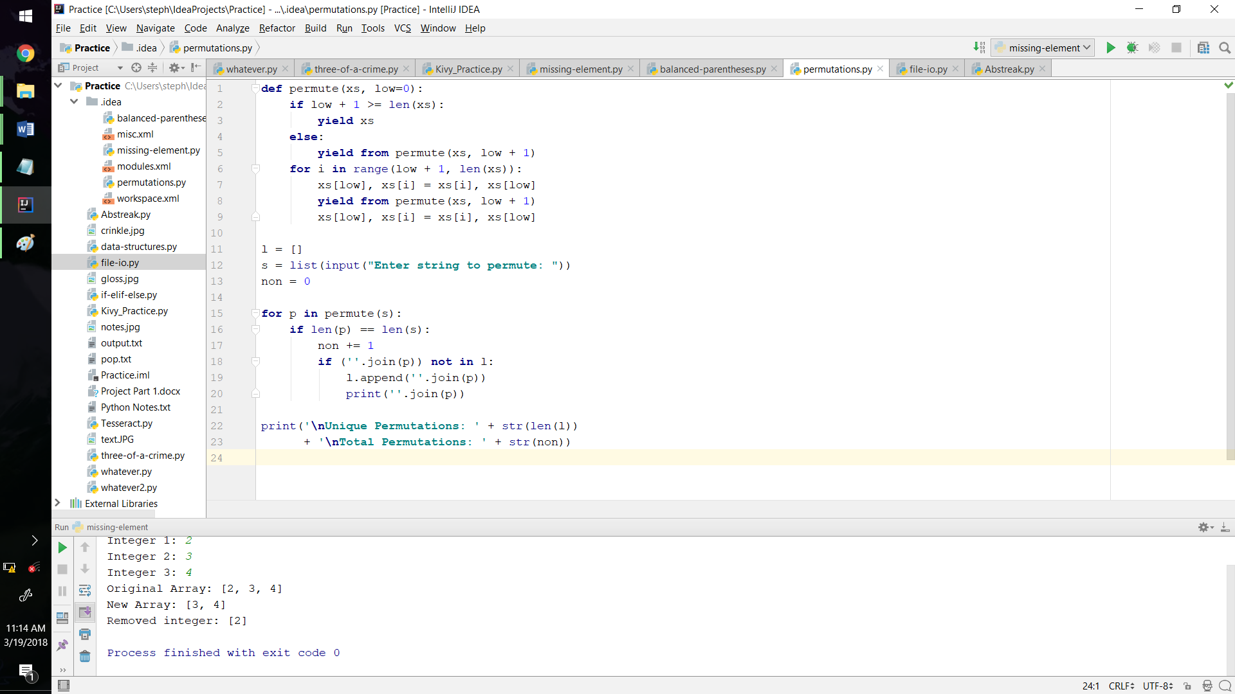Prompt for string to permute ->

generate permutations incrementally using nested for loops -> discard repeat permutations -> display results

Using a generator function, which implements the yield reserved word, each unique permutation of a given string is displayed. A nested conditional statement checks if it has reached the last index of the string. If so, it yields the permutation. Otherwise, it yields the data from a recursive call to the next index. Then a for loop swaps the proper indices and recursively calls to the next index.

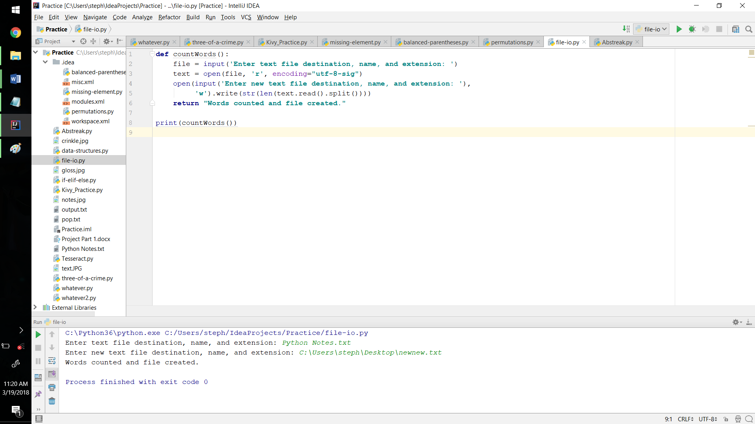File IO:

Prompt for input file ->

read text ->

create new text file with word count of input file -> display results

A function call to "countWords()" creates a new text file with writing privileges once the file is input and read, and the word count of the initial file (which was retrieved from within the same logical line) is written to it.

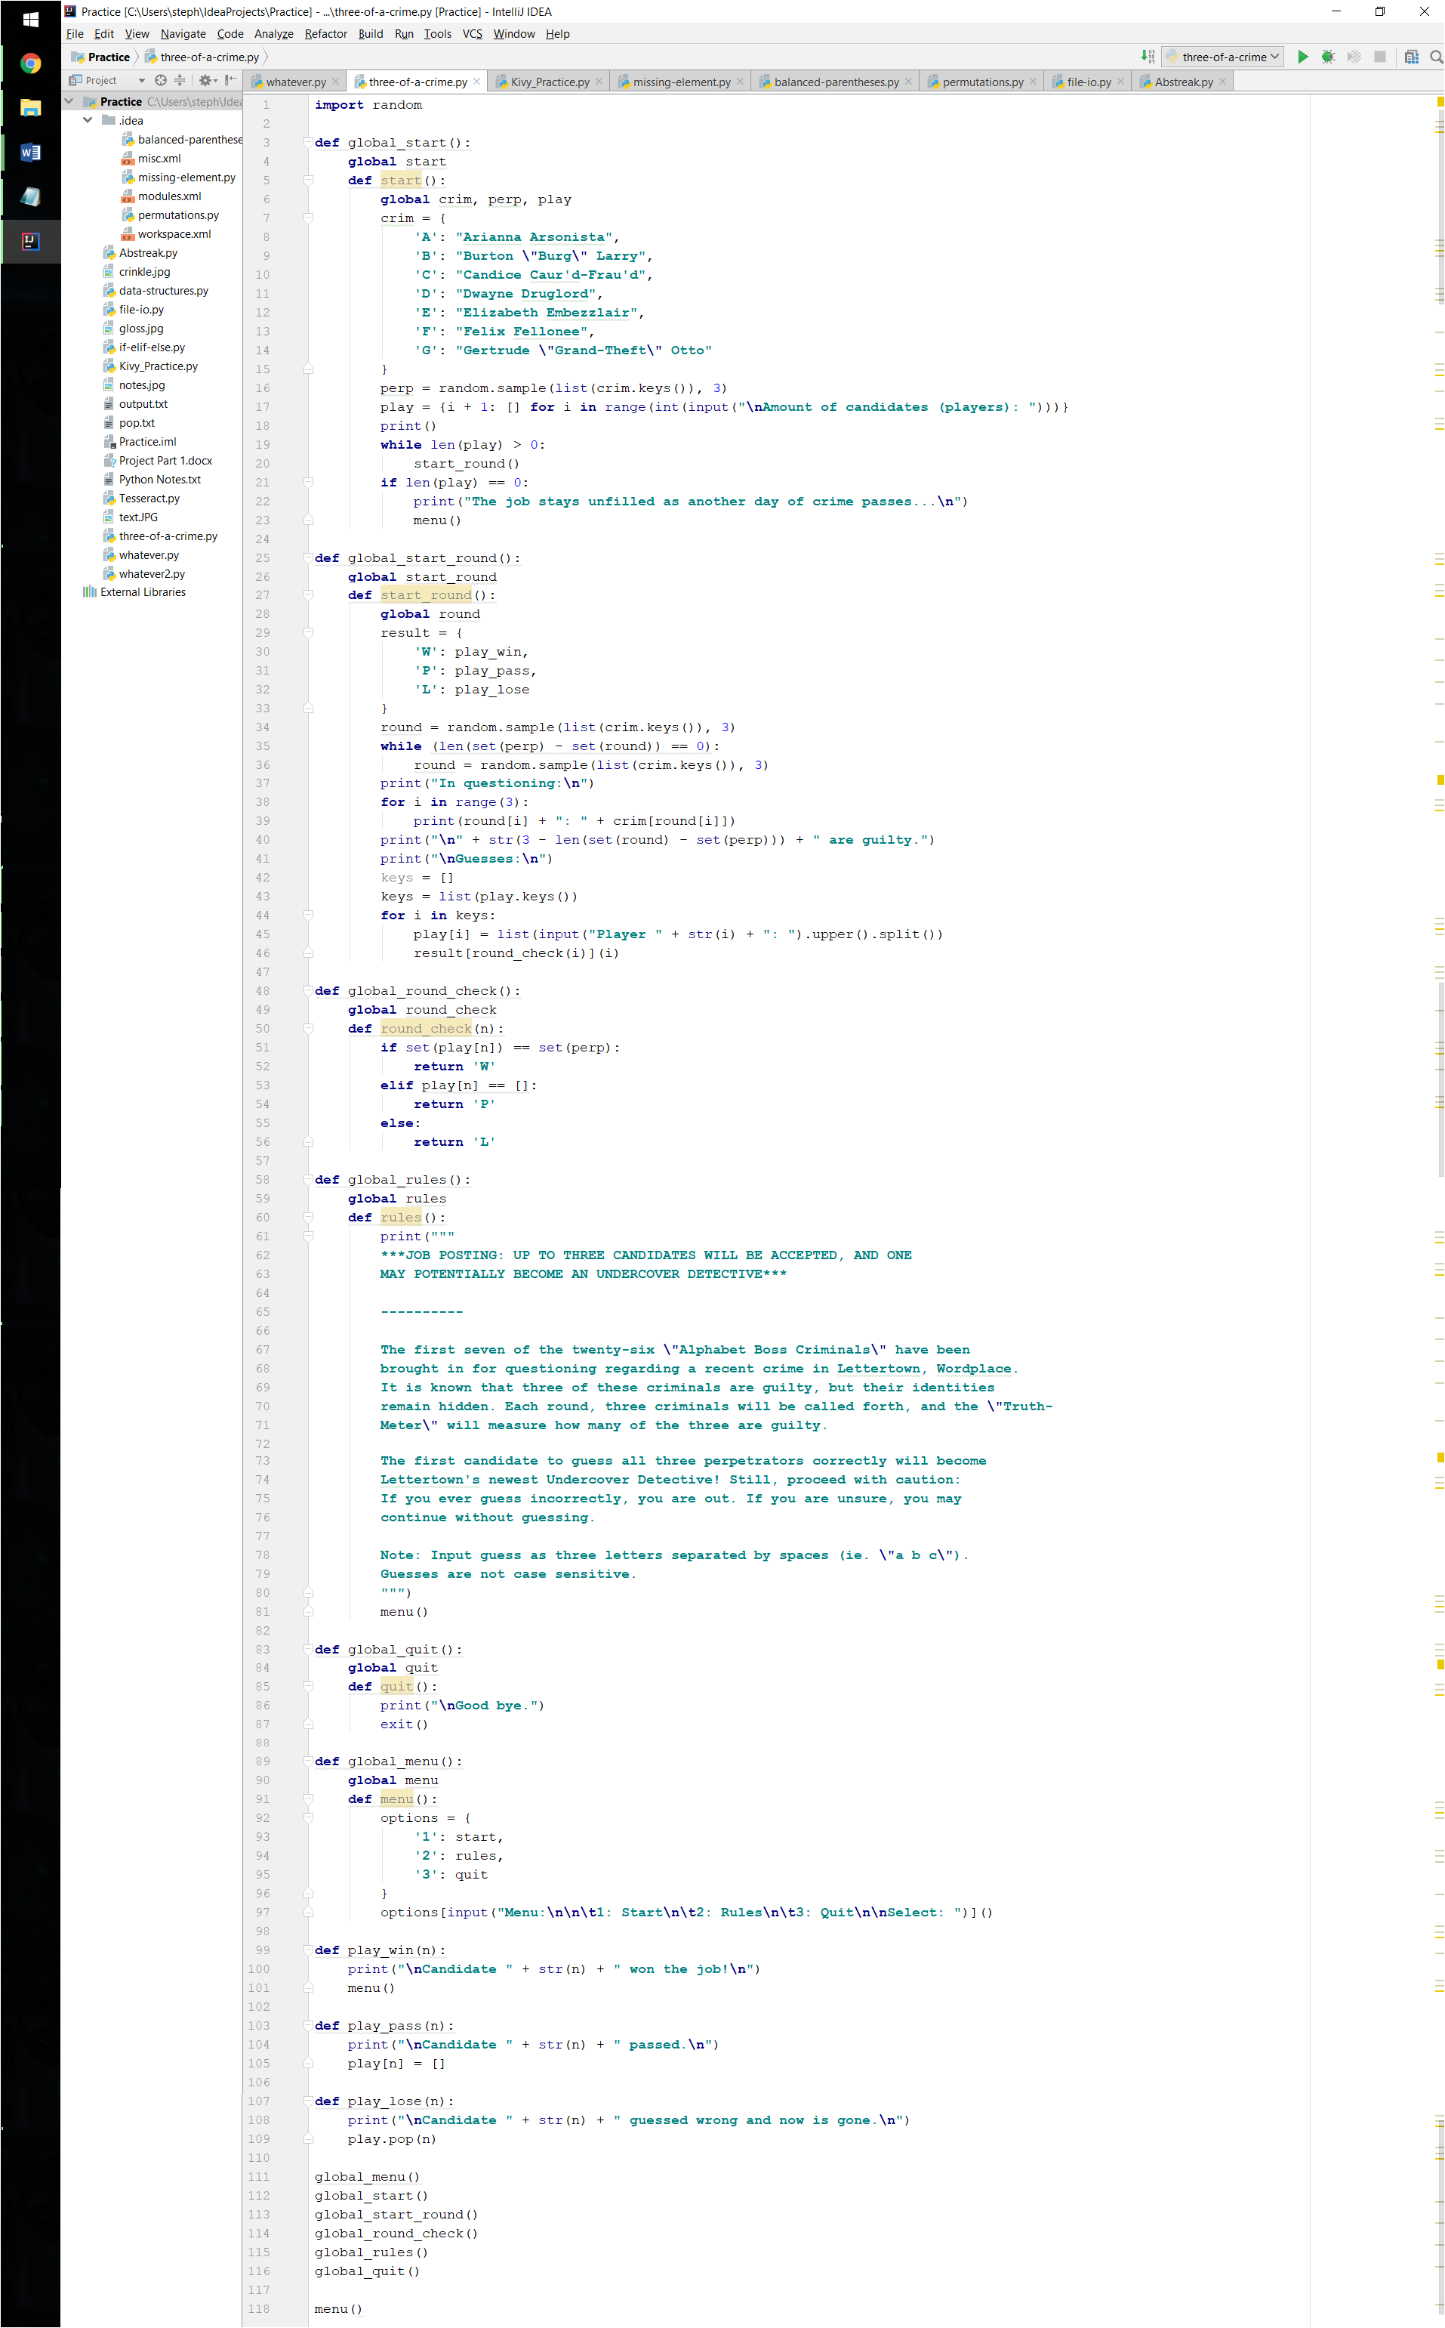3 of a Crime:

Set all user-defined functions and

necessary variables as global -> Display menu -> Execute choice (1: Start, 2: Rules, 3: Exit) -> Randomly choose three perpetrators -> prompt for

number of players -> Randomly select three

criminals and display amount that are

perpetrators -> process players' guess

(Incorrect: Remove player, Correct: Display winner, Pass: Continue) -> Repeat -> Display menu upon finish

To ensure data and function accessibility, all user-defined

functions and necessary variables to global. Then a

menu automatically displays, giving the user

three choices: "Start", "Rules", and "Quit". Upon

game commencement, the perpetrators and number of

players are established. During each round, each player's guess, if made, is checked with a function call to "round_check()", which uses a nested conditional statement. At the end of each game, the program displays the results and returns to the menu.